

MAWLANA BHASHANI SCIENCE AND TECHNOLOGY UNIVERSITY
Santosh, Tangail-1902
Assignment

Department of : Information and Communication Technology
Assignment No : 01
Name of the assignment : Chapter 1-3
Course Title : Cryptography and Cyber Law
Course Code : ICT4115

Submitted to
Dr. Ziaur Rahman
Professor

Dept. of ICT, MBSTU
Submitted by
Name : Kuldip Saha Mugdha
ID : IT22018 Session : 2021-22
Year : 4th Semester : 1st
Dept. of ICT, MBSTU

Date of Performance : 12/06/2026 Date of Submission : 24/06/2026
Chapter - 1

Q1. What is Cipher Security?
Ans: Cipher security refers to how strong an encryption scheme is against being broken. A cipher is considered secure if the cost of breaking it exceeds the value of the encrypted information, or the time required to break it exceeds the useful lifetime of the information. In simple terms, a cipher is secure if it is too expensive or too slow to crack.
Q2. What is Information Security?
Ans: Information Security is the protection of information to ensure Confidentiality (only authorized people can see it), Integrity (information is not changed without permission), and Availability (authorized users can access it when needed). It covers both digital and physical (paper-based) information.
Q3. What is Network Security?
Ans: Network Security is the protection of a network and its services from unauthorized access, modification, or destruction. It ensures the network works correctly without harmful interference. It has two main parts — Communications Security (protecting data traveling through the network) and Device Security (protecting routers and servers using firewalls and intrusion detection systems).
Q4. What is the difference between Block Cipher and Stream Cipher?
 | Block Cipher | Stream Cipher
Works on | Fixed blocks (128 bits) | One bit at a time
Speed | Slower | Faster
Operation | Depends on key + block content | Uses XOR operation
Security | More secure | Less secure
Example | AES, DES | RC4
Used for | File encryption | Real-time data (calls, video)
Q5. Define the three key objectives of Cybersecurity(CIA) along with figure .
Ans: The three key objectives of cybersecurity are known as the CIA Triad:
1. Confidentiality:
Ensures that private or sensitive information is not made available to unauthorized individuals. Only authorized people can access the information.
2. Integrity:
Ensures that information and systems are changed only in an authorized manner. It guarantees that data is accurate, complete, and not tampered with.
3. Availability:
Ensures that systems and information are accessible and usable by authorized users whenever they need it. A loss of availability means disruption of access to information or a system.

Q6. What is the OSI Security Architecture?
Ans: OSI Security Architecture is a framework that helps organizations define and organize their security needs. It has three main parts:
- Security Attack: Any action that harms or compromises the security of an organization's information.
- Security Mechanism: A process or tool used to detect, prevent, or recover from a security attack.
- Security Service: A service that improves the security of a system and uses security mechanisms to fight against attacks.
Q7. What is a Threat?
Ans: A threat is any possible danger or event that could harm an organization's information system. It can cause unauthorized access, data loss, or denial of service. Simply put, a threat is a potential risk that has not happened yet.
Q8. What is an Attack?
Ans: An attack is when someone actually tries to damage, steal, or destroy information from a system. It is the real action taken against a system to cause harm. Simply put, an attack is when a threat becomes reality.
Q9. What is a Security Attack and what are its types?
Ans: A security attack is any action that tries to harm or compromise the security of information owned by an organization. Security attacks are mainly of two types:
1. Passive Attack:
A passive attack only monitors or reads information without changing anything. The attacker just watches the data secretly. It is hard to detect but can be prevented by encryption.
Two types:
- Release of Message Contents — attacker reads private messages or files
- Traffic Analysis — attacker watches communication patterns even if message is encrypted
2. Active Attack:
An active attack actually modifies or disrupts the data or system. It is hard to prevent but can be detected.
Four types:
- Masquerade — attacker pretends to be someone else (fake identity)
- Replay — attacker captures a message and sends it again later
- Data Modification — attacker changes the original message content
- Denial of Service (DoS) — attacker blocks or overloads the system so no one can use it
Q10. What is Access Control?
Ans: Access control means only authorized and authenticated users can access a system or its resources. Unauthorized users are blocked.
Q11. What is Data Confidentiality?
Ans: Data confidentiality means keeping data private so unauthorized people cannot see or read it during transmission.
Q12. What is Data Integrity?
Ans: Data integrity ensures that data is not changed, deleted, or modified without permission during transmission or storage.
Q13. What is Nonrepudiation?
Ans: Nonrepudiation means a sender cannot deny sending a message and a receiver cannot deny receiving it. Both sides are accountable.
Q14. What is Availability Service?
Ans: Availability means a system must always be accessible to authorized users when they need it. DoS attacks can reduce availability.
Q15. What is Cryptography?
Ans: Cryptography is a branch of mathematics that transforms data to keep it secure. It is used for secure storage, transmission of data, and secure communication between parties.

Q16. What are the three categories of Cryptographic Algorithms?
Ans: Cryptographic algorithms are divided into three categories:
- Keyless: Does not use any key during transformation. Example: hash functions.
- Single-key: Uses one secret key for both encryption and decryption. Also called symmetric encryption.
- Two-key: Uses two related keys — a private key and a public key. Also called asymmetric encryption.

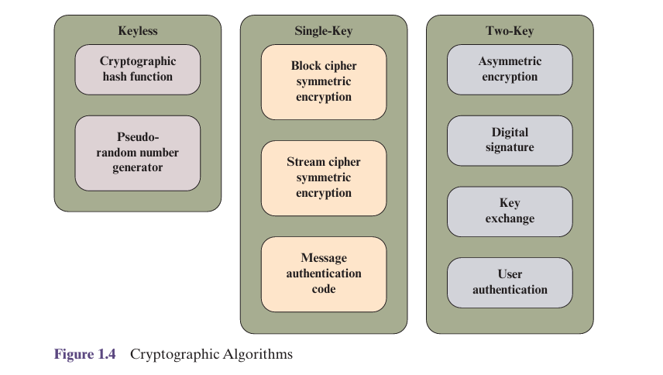
Q17. What is the difference between Block Cipher and Stream Cipher?
 | Block Cipher | Stream Cipher
Works on | Fixed blocks (128 bits) | One bit at a time
Speed | Slower | Faster
Operation | Depends on key + block content | Uses XOR operation
Security | More secure | Less secure
Example | AES, DES | RC4
Used for | File encryption | Real-time data (calls, video)

Q18. What are the three factors of Trustworthiness?
Ans: Three factors are used to measure trustworthiness:
- Ability — the entity is capable and competent enough to do the task
- Benevolence — the entity has good intentions and will not cause harm
- Integrity — the entity follows acceptable principles and acts honestly

Q19. What is the Trust Model?
Ans: The Trust Model explains how trust is formed between two parties. Trust depends on two things — the truster's propensity (how willing someone is to trust) and the perceived trustworthiness of the other party. Based on the level of trust and perceived risk, a party decides whether to rely on or share information with the other party.
The Trust Model diagram:

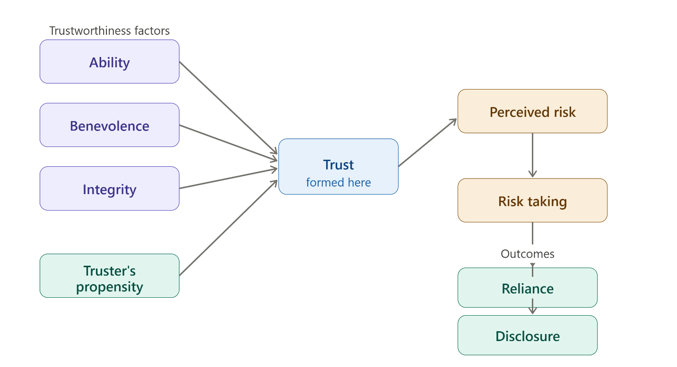

Chapter – 2
Introduction to Number Theory
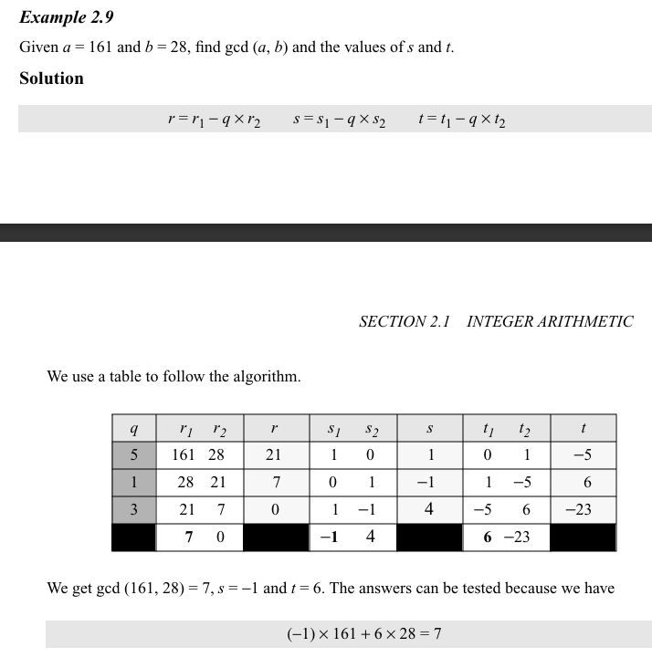
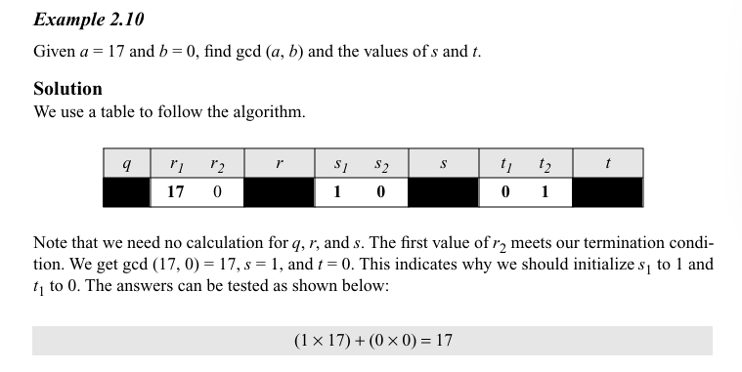
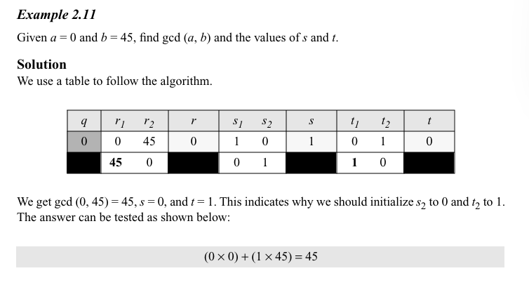
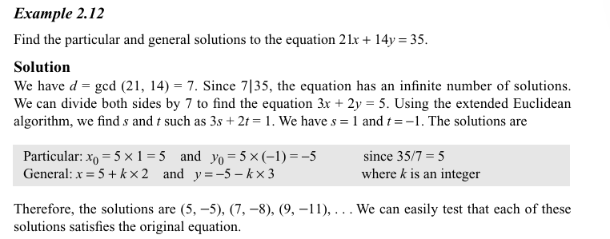
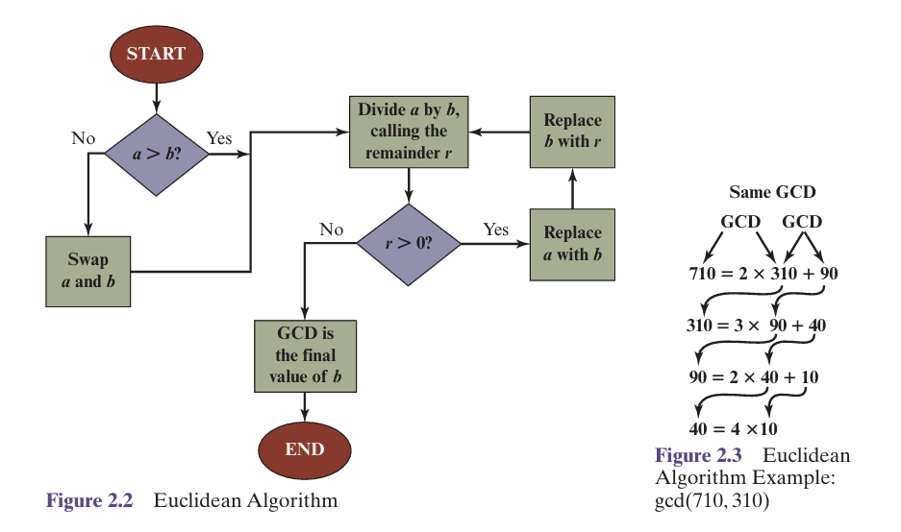

1. What does it mean to say that b is a divisor of a?
A number b is called a divisor of a if it divides a exactly without leaving any remainder.
Mathematically, b divides a (written as $b∣a$) if there exists an integer k such that:
$$a=b×k$$
Example:
$3∣12$because $12=3×4$, so 3 is a divisor of 12.

2. What is the meaning of the expression a divides b?
The expression “a divides b” means that a is a divisor of b, i.e., b is exactly divisible by a without any remainder.
Mathematically, it is written as $a∣b$, and it means there exists an integer k such that:
$$b=a×k$$
Example:
$4∣20$because $20=4×5$.

3. What is the difference between modular arithmetic and ordinary arithmetic?
The main difference between ordinary arithmetic and modular arithmetic lies in how numbers are treated after operations.
Ordinary Arithmetic:
- Deals with exact values.
- Results are not restricted.
- Example: $7+5=12$
Modular Arithmetic:
- Works with remainders after division by a fixed number (called the modulus).
- Results are taken modulo n.
- Example:
$$7+5=12≡2 (\text{mod }10)$$
Key Difference:
- Ordinary arithmetic gives the full result.
- Modular arithmetic gives the remainder after division by the modulus.

4. What is a prime number?
A prime number is a natural number greater than 1 that has exactly two distinct positive divisors: 1 and itself.
Example:
- 2, 3, 5, 7, 11 are prime numbers.
Explanation:
For example, 7 is a prime number because it is divisible only by 1 and 7, and no other numbers.

5. What is Euler’s totient function?
Euler’s totient function, denoted by $φ(n)$, is defined as the number of positive integers less than or equal to $n$that are coprime (relatively prime) to $n$.
Definition:
$$φ(n)=\text{number of integers }k (1≤k≤n)\text{ such that }gcd⁡(k,n)=1$$
Example:
For $n=9$:
Numbers are 1, 2, 3, 4, 5, 6, 7, 8, 9
Coprime to 9 are: 1, 2, 4, 5, 7, 8
So,
$$φ(9)=6$$
In simple words:
Euler’s totient function counts how many numbers up to $n$do not share any common factor with $n$except 1.

6. What is a primitive root of a number?
A primitive root of a number $n$is a number $g$such that its powers generate all integers that are coprime to $n$under modulo $n$.
Definition:
A number $g$is called a primitive root modulo $n$if every number coprime to $n$can be written as:
$$g^{k} (\text{mod }n)$$
for some integer $k$.
In simple words:
A primitive root is a number whose repeated powers (mod $n$) produce all numbers that are relatively prime to $n$.
Example:
For $n=7$, the primitive root is $3$, because:
- $3^{1}≡3mod 7$
- $3^{2}≡2mod 7$
- $3^{3}≡6mod 7$
- $3^{4}≡4mod 7$
- $3^{5}≡5mod 7$
- $3^{6}≡1mod 7$
So, it generates all numbers from 1 to 6 (which are coprime to 7).

7. In this text, we assume that the modulus is a positive integer. But the definition of the expression a mod n also makes perfect sense if n is negative. Determine the following:
a. 7 mod 4
b. 7 mod -4
c. -7 mod 4
d. -7 mod -4
We use the standard rule:
For a mod n, the result is the remainder r such that
$$a=nq+r$$
and $r$is chosen so that $0≤r<∣n∣$.
So we always take the remainder in the range 0 to |n| − 1, even if $n$is negative.
a) $7 mod 4$
$$7=4×1+3$$
So,
Answer: 3
b) $7 mod (-4)$
Here $∣n∣=4$, so remainder must be $0≤r<4$
Try:
$7=(-4)(-2)+(-1)$❌ (remainder negative, not allowed)
Correct form:
$$7=(-4)(-1)+3$$
So,
Answer: 3
c) $-7 mod 4$
$∣n∣=4$, so $0≤r<4$
$$-7=4(-2)+1$$
So,
Answer: 1
d) $-7 mod (-4)$
Again $∣n∣=4$
$$-7=(-4)(2)+1$$
So,
Answer: 1

8. What is the smallest positive integer that has exactly k divisors? Provide answers for values for 1<=k<=8.
We want the smallest positive integer having exactly $k$divisors for $1≤k≤8$.
Using the divisor-count formula:
If
$$n=p_{1}^{a_{1}}p_{2}^{a_{2}}⋯$$
then number of divisors is:
$$d(n)=(a_{1}+1)(a_{2}+1)⋯$$
We choose the smallest number by using smallest primes with exponents arranged in decreasing order.
Answers:
k | Smallest integer with exactly k divisors
1 | 1
2 | 2
3 | 4 (= $2^{2}$)
4 | 6 (= $2×3$)
5 | 16 (= $2^{4}$)
6 | 12 (= $2^{2}×3$)
7 | 64 (= $2^{6}$)
8 | 24 (= $2^{3}×3$)

9. Determine gcd(72345, 43215)
We use the Euclidean Algorithm:
Step 1:
$$72345-43215=29130$$
$$gcd⁡(72345,43215)=gcd⁡(43215,29130)$$
Step 2:
$$43215-29130=14085$$
$$gcd⁡(43215,29130)=gcd⁡(29130,14085)$$
Step 3:
$$29130-2×14085=29130-28170=960$$
$$gcd⁡(29130,14085)=gcd⁡(14085,960)$$
Step 4:
$14085÷960=14$remainder $645$
$$gcd⁡(14085,960)=gcd⁡(960,645)$$
Step 5:
$$960-645=315$$
$$gcd⁡(960,645)=gcd⁡(645,315)$$
Step 6:
$$645=2×315+15$$
$$gcd⁡(645,315)=gcd⁡(315,15)$$
Step 7:
$315÷15=0$remainder $0$
So,
$$gcd⁡=15$$
10. Determine gcd(3486, 10292)
Step 1:
$$10292=3486×2+3320$$
$$gcd⁡(10292,3486)=gcd⁡(3486,3320)$$Step 2:
$$3486=3320×1+166$$
$$gcd⁡(3486,3320)=gcd⁡(3320,166)$$ Step 3:
$$3320=166×20+0$$
So,
$gcd⁡(3320,166)=166$ Final Answer: 166
11. Using Fermat’s theorem, find 4²²⁵ mod 13.
We use Fermat’s Little Theorem:
Since 13 is prime and $4$is not divisible by 13,
$$4^{12}≡1(mod13)$$Step 1: Reduce the exponent
$$225=12×18+9$$
So,
$$4^{225}=(4^{12})^{18}⋅4^{9}$$
Using Fermat:
$$\left(4^{12})^{18} ≡ 1^{18} ≡ 1\right.$$
So,
$$4^{225}≡4^{9}(mod13)$$Step 2: Compute $4^{9}mod 13$
$$4^{2}=16≡3(mod13) \\ 4^{4}=3^{2}=9 \\ 4^{8}=9^{2}=81≡3(mod13) \\ 4^{9}=4^{8}⋅4≡3⋅4=12$$Final Answer: 12

Question 1
(a) Prove Fermat’s Little Theorem and explain how it is used to test for primality. Is 561 a prime number based on this test? Evaluate 5^123 mod 175 using Fermat’s Little Theorem.
(b) State and prove the Chinese Remainder Theorem. Then solve:
x ≡ 2 (mod 3), x ≡ 3 (mod 5), x ≡ 2 (mod 7)
(c) Determine the multiplicative inverse of 7 mod 26 using Extended Euclidean Algorithm.
(d) Find x such that 43x ≡ 1 (mod 240)

Solutions

(a) Fermat’s Little Theorem
Statement
If $p$is prime and $a≢0(modp)$, then
$$a^{p-1}≡1(modp)$$
Proof (short form)
Consider the set:
$$\left\{1,2,3,…,p-1\right\}$$
Multiply each element by $a$:
$$\{a,2a,3a,…,(p-1)a\}(modp)$$
These are all distinct modulo $p$, so:
$$a^{p-1}(p-1)!≡(p-1)!(modp)$$
Cancel $(p-1)!$:
$$a^{p-1}≡1(modp)$$
Primality Test using FLT
If $p$is prime →
$$a^{p-1}≡1(modp)$$
If NOT true → definitely composite
If true → probably prime (not guaranteed)

Check: Is 561 prime?
Take $a=2$
$$2^{560}mod 561$$
Result:
$$2^{560}≡1(mod561)$$
But 561 = 3 × 11 × 17 → composite
👉 So 561 is NOT prime, but it passes the test.
➡️ It is a Carmichael number

Evaluate $5^{123}mod 175$
Factor:
$$175=5^{2}×7$$
Use Chinese Remainder Theorem (CRT)
Step 1: mod 25
$$5^{123}≡0(mod25)$$Step 2: mod 7
Use FLT:
$$5^{6}≡1(mod7) \\ 123mod 6=3 \\ 5^{123}≡5^{3}=125≡6(mod7)$$Step 3: Solve
$$x≡0(mod25),x≡6(mod7)$$
Let:
$$x=25k \\ 25k≡6(mod7) \\ 4k≡6(mod7)$$
Inverse of 4 mod 7 = 2
$$k=6×2=12≡5(mod7) \\ k=5⇒x=125$$✅ Final Answer
$$5^{123}≡125(mod175)$$

(b) Chinese Remainder Theorem
Solution:
Statement
If moduli are pairwise coprime, system:
$$x≡a_{i}(modn_{i})$$
has a unique solution mod $N=∏n_{i}$
Solve:
$$x≡2(mod3) \\ x≡3(mod5) \\ x≡2(mod7)$$
Step 1: Combine first two
Let:
$$x=3k+2$$
Substitute:
$$3k+2≡3(mod5) \\ 3k≡1(mod5)$$
Inverse of 3 mod 5 = 2
$$k=2 \\ x=3(2)+2=8$$
So:
$$x≡8(mod15)$$
Step 2: Combine with third
$$x=15t+8 \\ 15t+8≡2(mod7) \\ t+1≡2(mod7) \\ t=1 \\ x=15(1)+8=23$$✅ Final Answer
$$x≡23(mod105)$$

(c) Multiplicative Inverse
Use Extended Euclidean Algorithm:
$$26=3×7+57=1×5+25=2×2+12=2×1+0$$
Back substitute:
$$1=5-2×2=5-2(7-5)=3×5-2×7=3(26-3×7)-2×7=3×26-11×7 \\ -11×7≡1(mod26) \\ 7^{-1}≡-11≡15(mod26)$$✅ Answer
$$7^{-1}≡15(mod26)$$

(d) Linear Congruence
Solution:
Use Extended Euclid:
$$240=5×43+2543=1×25+1825=1×18+718=2×7+47=1×4+34=1×3+1$$
Back substitute:
$$1=4-3=4-(7-4)=2×4-7=2(18-2×7)-7=2×18-5×7=2×18-5(25-18)=7×18-5×25=7(43-25)-5×25=7×43-12×25=7×43-12(240-5×43)=67×43-12×240 \\ 43×67≡1(mod240)$$✅ Final Answer
$$x≡67(mod240)$$

Chapter 3

Q1. What is Traditional Symmetric Key Cipher? Provide detailed explanation.
Ans: A Traditional Symmetric Key Cipher is an encryption technique in which the same secret key is used for both:
- Encryption (converting plaintext into ciphertext)
- Decryption (converting ciphertext back into plaintext)
The sender and receiver must share the same secret key before communication.
Example
Suppose:
Plaintext = HELLO
Key = 3
Using a Caesar Cipher (shift by 3):
H → K
E → H
L → O
L → O
O → R
Ciphertext:
KHOOR
Using the same key (3) for decryption:
KHOOR → HELLO

Q2: Explain the ingredients of a symmetric encryption scheme.
Ans:
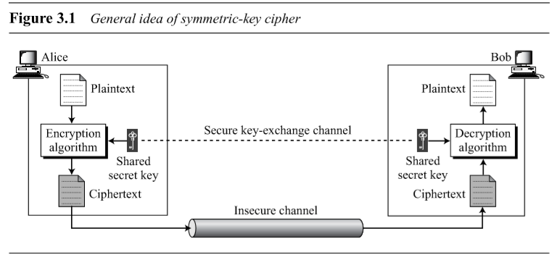

A symmetric encryption scheme has five ingredients:
■Plaintext: This is the original intelligible message or data that is fed into the algorithm as input.
■ Encryption algorithm: The encryption algorithm performs various substitutions and transformations on the plaintext.
■ Secret key: The secret key is also input to the encryption algorithm. The key is a value independent of the plaintext and of the algorithm. The algorithm will produce a different output depending on the specific key being used at the time. The exact substitutions and transformations performed by the algorithm depend on the key.
■ Ciphertext: This is the scrambled message produced as output. It depends on the plaintext and the secret key. For a given message, two different keys will produce two different ciphertexts. The ciphertext is an apparently random stream of data and, as it stands, is unintelligible.
■ Decryption algorithm: This is essentially the encryption algorithm run in reverse. It takes the ciphertext and the secret key and produces the original plaintext.

Q3. Types of Traditional Symmetric Ciphers
Ans: 1. Substitution Cipher
Each letter is replaced by another letter.
Example:
A → D
B → E
C → F
Examples:
- Caesar Cipher
- Monoalphabetic Cipher
- Playfair Cipher
- Vigenère Cipher
2. Transposition Cipher
Letters remain the same but their positions are changed.
Example:
Plaintext: HELLO
Ciphertext: ELHLO
Examples:
- Rail Fence Cipher
- Columnar Transposition Cipher

Q4. Explain Kerckhoffs' Principle
Ans: Kerckhoffs' Principle states that a cryptographic system should remain secure even if all details of the encryption algorithm are publicly known, provided that the secret key remains confidential. Thus, the security of a cryptosystem should depend only on the secrecy of the key and not on the secrecy of the algorithm. The resistance of the cipher to attack must be based only on the secrecy of the key.

Q5. Explain Cryptoanalysis and cryptanalysis attacks.
Ans:
Cryptanalysis is the process of analyzing and breaking cryptographic systems to recover plaintext, keys, or other secret information without authorization. It is used to evaluate the security of cryptographic algorithms, identify weaknesses, and improve encryption methods.
Types of cryptanalysis attacks are given below:
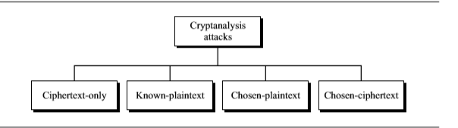

1.Ciphertext-only attack(COA):
In this type of attack, attacker has only access to the ciphertext. And tries to find corresponding key and plaintext. The assumption is that attacker knows the algorithm and can intercept the ciphertext. This method is often limited to a partial key recovery rather than a full decryption.
Example
Ciphertext:
KHOOR
The attacker knows it is encrypted using a Caesar Cipher but does not know the key.
He tries all 25 possible shifts:
Shift 1 → JGNNQ
Shift 2 → IFMMP
Shift 3 → HELLO
The correct plaintext is found.
2. Known-Plaintext Attack (KPA)
In a Known-Plaintext Attack, the attacker has access to one or more pairs of plaintext and their corresponding ciphertext. Using these known pairs, the attacker attempts to discover the encryption key and then decrypt other encrypted messages that use the same key.
Example
Known Plaintext
HELLO
Corresponding Ciphertext
KHOOR
The attacker compares the two messages.
H → K (+3)
E → H (+3)
L → O (+3)
From this comparison, the attacker determines that the encryption key is Shift = 3.
Now, if another ciphertext is intercepted:
PHHW
The attacker decrypts it using Shift 3.
PHHW → MEET
Thus, other encrypted messages can also be decrypted.
3. Chosen-Plaintext Attack (CPA)
In this attack, the attacker can choose any plaintext and request the encryption system to encrypt it. By observing the resulting ciphertexts, the attacker analyzes the encryption process and attempts to discover the secret key or weaknesses in the algorithm.
Example
The attacker submits the following plaintext:
AAAA
The encryption system returns:
DDDD
The attacker then submits:
BBBB
The encryption system returns:
EEEE
From the results:
A → D (+3)
B → E (+3)
The attacker concludes that the cipher uses a Shift = 3.
Using this knowledge, future ciphertexts encrypted with the same key can be decrypted.
4. Chosen-Ciphertext Attack (CCA)
In a Chosen-Ciphertext Attack, the attacker is allowed to choose ciphertexts and obtain their decrypted plaintexts from the decryption system. By analyzing these plaintexts, the attacker attempts to determine the secret key or break the encryption scheme.
Example
The attacker sends the ciphertext:
KHOOR
The decryption device returns:
HELLO
Next, the attacker submits:
PHHW
The system returns:
MEET
By repeatedly sending carefully selected ciphertexts and observing the decrypted outputs, the attacker gains information that may reveal the encryption key or expose weaknesses in the encryption algorithm.

Q6. Explain Brute Force Attack.
Ans: A Brute Force Attack is a cryptanalysis attack in which the attacker tries every possible encryption key until the correct one is found. Unlike other attacks, it does not exploit weaknesses in the encryption algorithm; instead, it relies on repeatedly testing keys. If enough time and computing power are available, brute force is guaranteed to find the correct key.
Assumption
The attacker:
- Knows the encryption algorithm.
- Has access to the ciphertext.
- Does not know the secret key.
- Tries every possible key one by one until the plaintext is successfully recovered.

Example
Suppose the ciphertext is:
KHOOR
The attacker knows it was encrypted using a Caesar Cipher but does not know the key.
The attacker tries all possible keys:
Key 1 → JGNNQ
Key 2 → IFMMP
Key 3 → HELLO ✓
When Key = 3, the ciphertext is correctly decrypted as:
HELLO
Thus, the attacker successfully discovers both the key (3) and the original plaintext (HELLO).

Q7. Explain substitution technique.
Ans: Substitution techniques are encryption methods in which each letter, number, or symbol in the plaintext is replaced (substituted) with another letter, number, or symbol according to a specific rule or key. The positions of the characters remain the same; only their values change.
Types of Substitution Techniques
1. Caesar Cipher (Shift Cipher)
2. Monoalphabetic Cipher
3. Playfair Cipher
4. Hill Cipher
5. Polyalphabetic Cipher (Vigenère Cipher)

Q8. What is Ceaser Cipher? Explain with example.
Ans: The Caesar Cipher is one of the simplest and oldest encryption techniques. It is a substitution cipher in which each letter of the plaintext is replaced by another letter by shifting fixed number of positions. The fixed number of positions is called the key or shift.
It was named after Julius Caesar, who reportedly used it to send secret military messages.
Mathematical Formula
Encryption
C = (P+K) mod 26
Where:
- C = Ciphertext letter
- P = Plaintext letter (A = 0, B = 1, ..., Z = 25)
- K = Key (shift value)
Decryption
P=(C−K) mod 26
Example
Plaintext:
HELLO
Shift = 3
H → K
E → H
L → O
L → O
O → R
Ciphertext:
KHOOR

Q9. What is Playfair Cipher? Explain with example.
Ans: The Playfair Cipher is a digraph substitution cipher, meaning it encrypts two letters (a pair or digraph) at a time instead of one letter at a time. It uses a 5 × 5 matrix of letters generated from a keyword. Since the English alphabet has 26 letters, the letters I and J are treated as the same letter to fit into the 25-cell matrix.
Compared to the Caesar Cipher and Monoalphabetic Cipher, the Playfair Cipher is more secure because it encrypts pairs of letters rather than individual letters.
Example
Keyword:
MONARCHY
The generated matrix is:
M O N A R
C H Y B D
E F G I K
L P Q S T
U V W X Z
Plaintext:
HI
Ciphertext:
BF

Q10. Explain Affine cipher with example.
Ans: The Affine Cipher is a type of monoalphabetic substitution cipher that encrypts each letter of the plaintext using a mathematical formula. Unlike the Caesar Cipher, which only shifts letters, the Affine Cipher combines multiplication and addition to produce the ciphertext, making it more secure than a simple shift cipher.
Each letter is first converted into a number:
Letter | A | B | C | D | E | F | G | H | I | J | K | L | M | N | O | P | Q | R | S | T | U | V | W | X | Y | Z
Value | 0 | 1 | 2 | 3 | 4 | 5 | 6 | 7 | 8 | 9 | 10 | 11 | 12 | 13 | 14 | 15 | 16 | 17 | 18 | 19 | 20 | 21 | 22 | 23 | 24 | 25

Encryption Formula
The Affine Cipher uses the following formula:
C=(ax+b) mod 26
Note: The value of a must be coprime with 26 (e.g., 1, 3, 5, 7, 9, 11, 15, 17, 19, 21, 23, 25). Otherwise, decryption is not possible.
Example
Plaintext
HELLO
Choose the keys:
a = 5
b = 8
Ciphertext
RCLLA

Q11. Explain Hill cipher with example.
Ans: The Hill Cipher is a polygraphic substitution cipher that encrypts a block of letters at a time using matrix multiplication and modular arithmetic. It was invented by Lester S. Hill in 1929.
Unlike the Caesar Cipher, which encrypts one letter at a time, the Hill Cipher encrypts two or more letters together, making it more resistant to frequency analysis.
Example
Plaintext:
HI
Convert to numbers:
H = 7
I = 8
Using the key matrix:
|3 3|
|2 5|
After matrix multiplication and modulo 26 operations, the ciphertext becomes:
TC

Q12. Explain Transposition Techniques.
Ans: Transposition techniques are encryption methods in which the positions of the plaintext characters are rearranged according to a specific rule or key, while the characters themselves remain unchanged. Unlike substitution techniques, no letter is replaced by another letter; only their order changes.

Abstract Algebra

Q1. What is Abstract Algebra?
Ans: Abstract Algebra is a branch of mathematics that studies algebraic structures such as groups, rings, fields, and modules. It focuses on understanding the properties and operations within these structures, rather than specific numbers.
Q2. What are the key structures in Abstract Algebra?
Ans: Some of the key structures in abstract algebra are:
- Groups
- Rings
- Fields
- Modules
Q3: What is Group? Give proper explanation.
Ans:
Group
A group is a set G together with a binary operation (*) that satisfies the following four properties:
- Closure: For all a, b in G, a * b is also in G.
- Associativity: For all a, b, c in G, (a * b) * c = a * (b * c).
- Identity: There exists an element e in G such that a * e = e * a = a for all a in G.
- Inverse: For every element a in G, there exists an element b in G such that a * b = b * a = e.
Example: The set of integers Z under addition (+) forms a group because:
- The sum of two integers is an integer (closure).
- Addition is associative.
- 0 is the identity element.
- Every integer a has an inverse −a such that a + (−a) = 0.
Types of Groups
In group theory, groups are classified into different types based on their properties and structure. Some common types of groups are:
- Abelian Group: A group is called Abelian (or commutative) if the operation satisfies a * b = b * a for all elements a and b in the group.
- Cyclic Group: A group is cyclic if all its elements can be generated by a single element called a generator.
- Finite Group: A group is finite if it contains a finite number of elements.
- Infinite Group: A group is infinite if it contains an infinite number of elements.
- Simple Group: A group is simple if it has no normal subgroups other than the trivial group and the group itself.
- Symmetric Group: The symmetric group Sₙ is the group of all permutations of n elements.
Q4. What is Ring? Give proper explanation.
Ans:
Rings
A ring RRR is a set equipped with two binary operations, usually called addition (+++) and multiplication (⋅ ⋅), satisfying the following properties:
- Addition Properties:
  - Closure: For all a, b ∈ R, a + b ∈ R.
  - Associativity: For all a, b, c ∈ R, (a + b) + c = a + (b + c).
  - Identity Element: There exists an element 0 ∈ R such that for every a ∈ R, a + 0 = 0 + a = a. This is called the additive identity.
  - Inverse Element: For each a ∈ R, there exists an element −a ∈ R such that a + (−a) = (−a) + a = 0. This is called the additive inverse.
  - Commutativity: For all a, b ∈ R, a + b = b + a.
- Multiplication Properties:
  - Closure: For all a, b ∈ R, a ⋅ b ∈ R.
  - Associativity: For all a, b, c ∈ R, (a ⋅ b) ⋅ c = a ⋅ (b ⋅ c).

- Distributive Properties:
  - Left Distributivity: For all a, b, c ∈ R, a ⋅(b + c) = (a ⋅ b) + (a ⋅ c).
  - Right Distributivity: For all a, b, c ∈ R, (a + b) ⋅ c = (a ⋅ c) + (b ⋅ c)

Q5. What is Field? Give proper explanation.
Ans:
Fields
A field F is a set equipped with two binary operations, addition (+) and multiplication (⋅), that satisfy the following properties:
- Addition Properties:
  - Closure: For all a, b ∈ F, a + b ∈ F.
  - Associativity: For all a, b, c ∈ F, (a + b) + c = a + (b + c).
  - Identity Element: There exists an element 0 ∈ F such that for every a ∈ F, a + 0 = 0 + a = a. This is called the additive identity.
  - Inverse Element: For each a ∈ F, there exists an element −a ∈ F such that a + (−a) = (−a) + a = 0. This is called the additive inverse.
  - Commutativity: For all a, b ∈ F, a + b = b + a.
- Multiplication Properties:
  - Closure: For all a, b ∈ F, a ⋅ b ∈ F.
  - Associativity: For all a, b, c ∈ F, (a ⋅ b) ⋅ c = a ⋅ (b ⋅ c).
  - Identity Element: There exists an element 1 ∈ F, 1 ≠ 0, such that for every a ∈ F, a ⋅ 1 = 1 ⋅ a = a. This is called the multiplicative identity.
  - Inverse Element: For each a ∈ F, a ≠ 0, there exists an element a⁻¹ ∈ F such that a ⋅ a⁻¹ = a⁻¹ ⋅ a = 1. This is called the multiplicative inverse.
  - Commutativity: For all a, b ∈ F, a ⋅ b = b ⋅ a.

